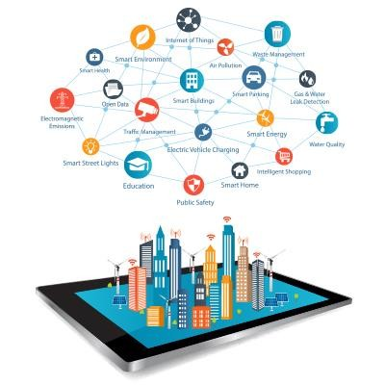

Environmental monitoring

By Desu Venkata Deekshith Reddy

711121106018

# Project Definition:

* The project involves setting up IoT devices to monitor environmental conditions in public parks, including temperature and humidity. The primary objective is to provide real-time environmental data to park visitors through a public platform, enabling them to plan their outdoor activities accordingly. This project includes defining objectives, designing the IoT sensor system, developing the environmental monitoring platform, and integrating them using IoT technology and Python.

# Design Thinking:

* + 1. Project Objectives: Define objectives such as real-time environmental monitoring, aiding park visitors in activity planning, promoting outdoor experiences, and enhancing visitor satisfaction.
  + 2. IoT Devices Designs: Plan the deployment of lot sensors (e.g., temperature and humidity sensors) in public parks.

■

* + 3. Environmental Monitoring Platform: Design a web-based platform to display real time environmental data to the public.

■

* + 4. Integration Approach: Determine how loT devices will send data to the environmental monitoring platform.

# Project Objectives

Define the Primary Objectives Secondary Goals and Benefits

How the Project Benefits Park Visitors

# IoT Sensor System Design

* Explanation of IoT (Internet of Things)
* Hardware Components (Sensors, Microcontrollers)
* Sensor Placement and Coverage
* Power Supply and Connectivity

# Environmental Sensors

* Types of Sensors (Temperature, Humidity)
* Sensor Selection Criteria
* Calibration and Accuracy

# Data Collection and Transmission

* Data Sampling and Frequency
* Wireless Connectivity (Wi-Fi, LoRa, Cellular)
* Ensuring Data Security and Privacy

# Environmental Monitoring Platform

* Overview of the Monitoring Platform
* Development Tools and Technologies (Python, IoT Protocols)
* Real-time Data Processing

# User Interface

* User-Friendly Dashboard
* Features for Park Visitors
* Access via Web and Mobile Apps

# Data Visualization

* Graphs and Charts for Temperature and Humidity
* Historical Data Trends
* Forecasting Features

# Integration with Public Platform

* How the Data is Made Accessible to Park Visitors
* Public Platform Features and Accessibility
* Benefits of Public Engagement

# IoT Technology and Python

* Role of Python in Data Processing
* Handling Data Streams
* Scalability and Flexibility

# Real-world Impact

* Testimonials or Feedback from Park Visitors
* Improved Park Experience
* Sustainability and Environmental Awareness